Tres Rios Nature Festival 2024
February 24th & 25th
Estrella Regional Park, Goodyear Arizona
Another Tres Rios Nature Festival is in the books. This year it was held at Estrella Mountain Regional Park due to damage at the Baseline & Meridian Wildlife area from last years flow event in the Salt/Gila river. The festival was well attended and we were kept busy from the start with the early tours on both days being well attended. Folks from all over the country came out just for our bird walks. It is amazing how many folks were interested in what we are doing.

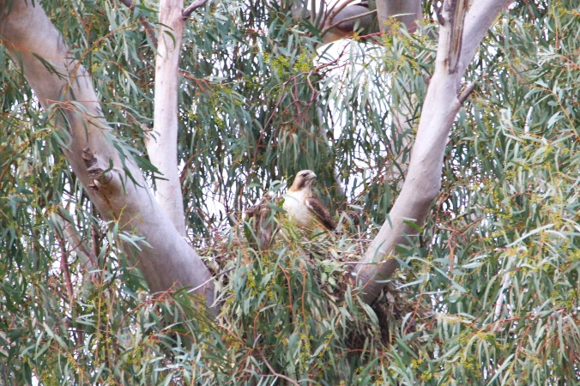 | We even had a young man of 12 years of age who was an incredibly knowledgeable birder! As for the birding, the park is a great place to see several species up-close. From RED-TAILED HAWKS building a nest in a large Eucalyptus tree (visible from our booth), to a large flock of LARK SPARROWS and DARK-EYED JUNCOS feeding on the lawn, to the PHAINOPEPLAS (Goth Cardinals) in the mistletoe. Several species were easy targets.

But the star of the festival was the VERMILLION FLYCATCHER! They were almost everywhere! It was easy to get six or more on a single hike. As the tour groups were admiring their antics, other festival goers would stop, pull out their cell phones, and photograph them as they were so close. The males would fly way up in the air doing silly displays in hopes the ladies would notice. | 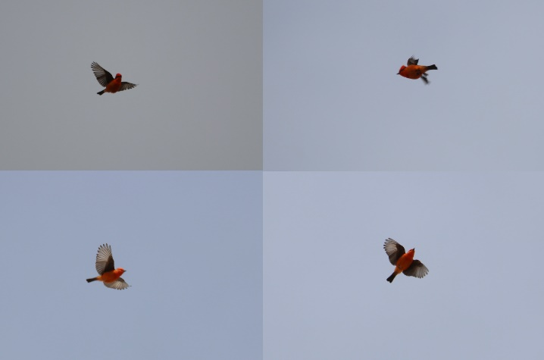

This brings us to the Fish and Game interview. AZ G&F are trying to get short interviews at each festival in Arizona. After two days of hikes, and knowing the Vermillion’s habits, I set the Video Photographer up in a spot that was as distracting as could be. He was able to get some great video of the Vermillion’s catching lunch. I am not sure when the video will air but if I find out I will let you know.
Many thanks to all of our booth and bird hike volunteers! Robert Carter, Jackie Anderson, Andre Tarby, Pete Herstein, tom locascio, Joe Ford, Elaine Alexander, Kathleen McCoy

Our bird list…
Gamble’s Quail, Eurasian Collared Dove, Mourning Dove, Anna’s Hummingbird, DC/Neo Cormorant, Great Blue Heron, White-faced Ibis, American White Pelican, Black Vulture, Turkey Vulture, Osprey, Red-tailed Hawk, Kestrel, Red-napped Sapsucker, Gila Woodpecker, Ladder-backed Woodpecker, Gilded Flicker, Say’s Phoebe, Vermillion Flycatcher, Ash-throated Flycatcher, Verdin, N. Rough-winged Swallow, Ruby-crowned Kinglet, Black-tailed Gnatcatcher, Blue-gray Gnatcatcher, Cactus Wren, E.U. Starling, Northern Mockingbird, Phainopepla, House Finch, Black, throated Sparrow, Lark Sparrow, White-crowned Sparrow, Dark-eyed Junco (Oregon), Yellow-rumped Sparrow, Orange-crowned Sparrow, Abert’s towhee, Lesser Goldfinch,

Due to some incidents in the river area, the gate to the riparian area is now closed.

Bob McCormick

